**MLOps Homework 2 - Email Classification**Modifying an existing email classification system to load classes from a file, allowing users to add new classes via an API, and demonstrating how the system works with additional classes.  
  
 **1. Clone the mlops_sentiment_lab repo**

<https://github.com/jhoward/mlops_sentiment_lab>  
  
 ANS: Cloned the repo in bash  
  
**2. Remove the hardcoded classes and change them to a ones that are loaded from a file**

1. **Created a classes.json file** to store class labels dynamically.



2. **Modified the code of Analyse.py:** to read the classes from classes.json instead of using hardcoded values.

3. **Implemented a function (load_classes())** that loads class labels from the file dynamically.  
  
4. **Classifying Example**:

**3. Allow users to add new classes via an API. This should update the class file:**  
  
ANS: To allow users to add new classes, I implemented an API using **Flask  
  
Flask API Code**:  
  
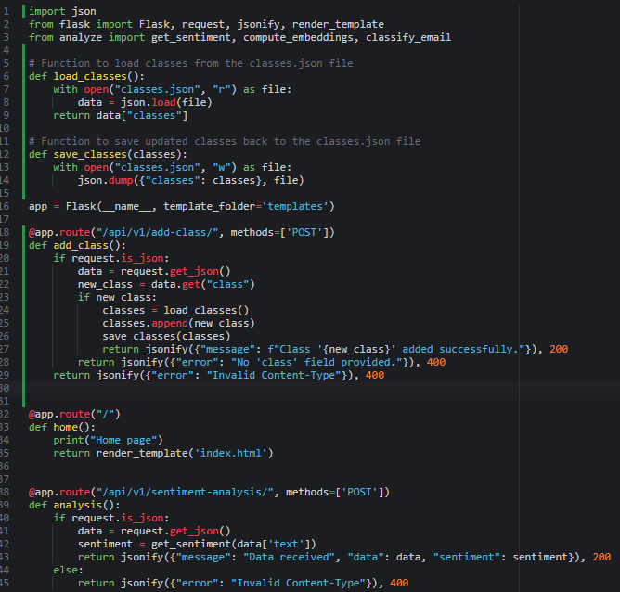

**Method**: POST  
  
When a POST request is made to the /add class endpoint, the system reads the class name from the JSON payload.  
  
appends the new class if it’s not already in the list, and saves the updated classes back to the file.

**4. Demonstrate this working with many additional classes. Invoke the  
classification endpoints with some different email text to show the system  
end 2 end.**  
  
ANS: We’ll be working with many additional classes:

Work,Sports,Food,Travel,Finance,Shopping,Health,Entertainment,Family,Education,Technology,Politics

After adding the new classes, I invoked the classification endpoint using curl to classify a sample email.  
  
**Email Text: "I am going to a football match tomorrow!"**  
  
$ curl -X POST http://127.0.0.1:3000/api/v1/classify/ -H "Content-Type: application/json" -d '{"text": "I am going to a football match tomorrow!"}'

({"classifications":[{"class":"Sports","similarity":0.33779534697532654},{"class":"Food","similarity":0.15516254305839539},{"class":"Work","similarity":0.1520056426525116},{"class":"Family","similarity":0.1493988037109375},{"class":"Entertainment","similarity":0.10950297117233276},{"class":"Finance","similarity":0.10245766490697861},{"class":"Politics","similarity":0.10082963109016418},{"class":"Health","similarity":0.09934098273515701},{"class":"Travel","similarity":0.09581462293863297},{"class":"Shopping","similarity":0.07858021557331085},{"class":"Education","similarity":0.07420410960912704},{"class":"Technology","similarity":0.026121918112039566}],"message":"Email classified"})  
  
The system automatically identifies the classes ("Sports" has more value) based on the text  
  
  
**Email Text: "I just got a promotion at work!"**  
  
The classification automatically detects "Work" has more value based on the job promotion text.  
**Email Text: "I just booked a flight for my vacation!The system detects "Travel" as the highest similarity due to the reference to vacation and flight booking.  
  
**Github Link: https://github.com/vsirigiri0828/Assignment-2**